James Keller – GES408 – Week 5 Lab Activity

Hypotheses: Finish filling these out! (1 point)
- H0: The slope of the relationship between % canopy cover and ground level PAR will be... zero
- H1: The slope of the relationship between % canopy cover and ground level PAR will be... negatively or positively correlated.
What do you expect the results to be? Give a brief (~1 sentence) ecological reason. (1 point)
I expect that as percent canopy cover increases, our ground level PAR will decrease because more of the light is being intercepted by the canopy.
Create a scatterplot of Canopy Cover vs PAR; add a linear regression line and 95% confidence interval. (1 point)
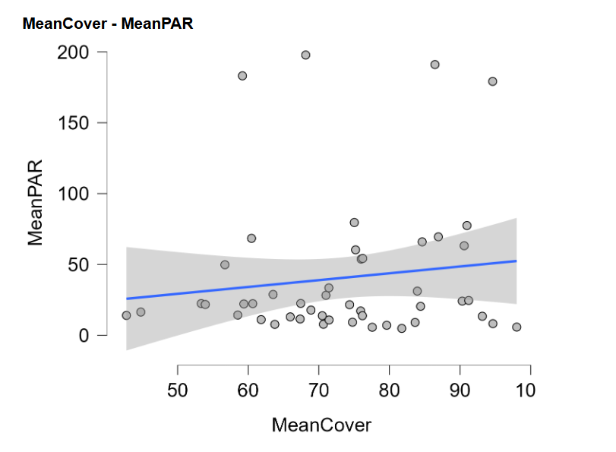

What is the regression equation? (1 point)
y = 0.482x + 5.152
Interpret the slope of your regression equation - what does it mean in ecological terms? (1 point)
The mean PAR increases by 0.482 for every percent increase in canopy cover.
What is the 95% confidence interval for your slope? Based on the interval, what can you conclude about the association between the variables? (1 point)
Our confidence interval is -0.6096 from 1.574. From this, we cannot reject our null hypothesis that the variables are not related.
What is the R² value for this model? Interpret this statistically/ecologically. (1 point)
Our R^2 value is 0.017. This means that 0.17% of the variation in PAR could be explained by percent canopy cover.
What is the p-value for this model? Can you reject your null hypothesis?. (1 point)
Our p-value is 0.379. We cannot reject our null hypothesis.
Display the residuals vs. predicted plot. If the assumptions of normality and equal variance of the residuals are met, then the plot should show the cloud of points as roughly symmetric above and below the line, with equal variance above and below the line. There also should be no curvature moving from left to right. Based on the plot, do you believe these assumptions are met? Explain. (2 points)
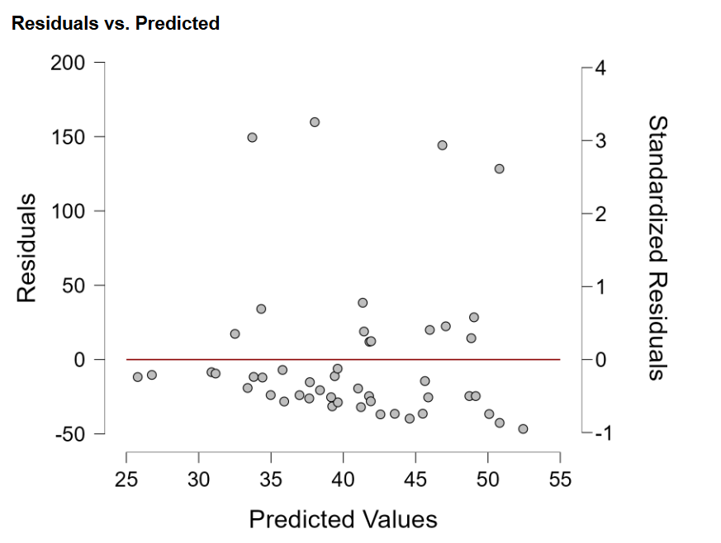
From the graph, I do not believe these assumptions are met. Our data is very clearly mostly under the line.
Display the Q-Q plot. This plot compares observations with the corresponding quantile expected from a normal distribution. If the data does not deviate from normality, the plot should show the points lining up with the diagonal line (with some wiggle room - they are often lightly scattered due to random sampling/variation). If there is significant curvature or jumps, this could indicate departures from normality. Looking at your plot, what do you think about the residuals - are they normally distributed? (1 point)
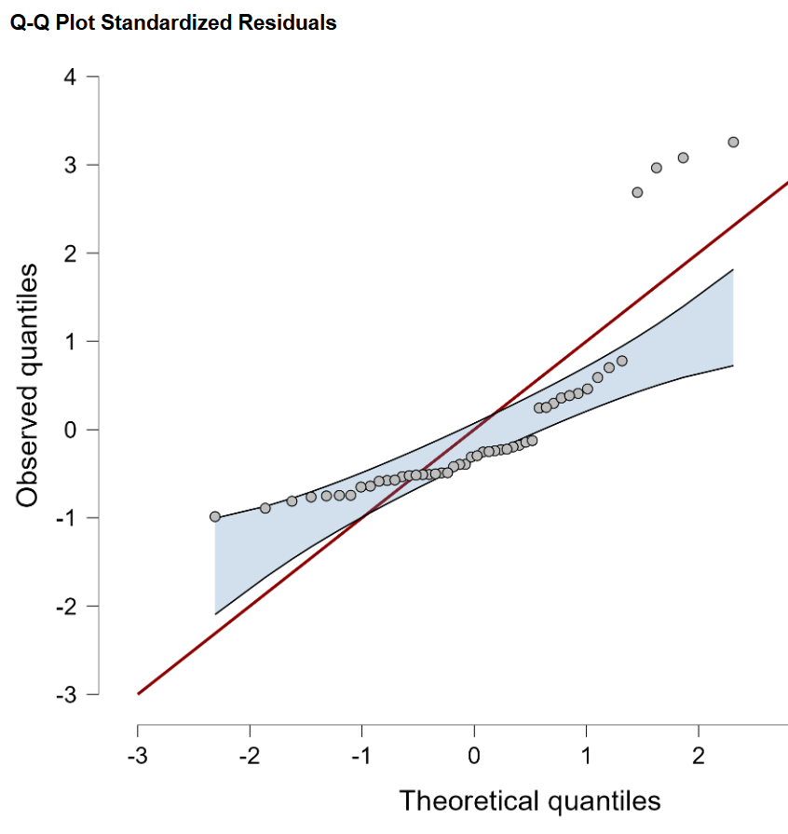
Our graph shows significant curvature and jumps which indicates that our data is NOT normally distributed.
Prediction: Whether our model is the best or not, give a point prediction for 50% canopy cover and provide an ecological interpretation of your prediction. (2 points)
y = 0.482x + 5.152 = 0.482(50) + 5.152 = 29.252 PAR

This means that according to our data, at a site where our canopy cover is 50%, we would expect to get a PAR value of 29.252.

Short discussion (≤200 words): (2 points) What ecological factors could confound this relationship? Describe at least one. Give at least one concrete way you might change or improve upon the design of this study. (Sampling, etc.)
Two things that could confound this relationship could be shiny/waxy leaves or time of day. The sun is at different angles at different times of day so the amount of sunlight hitting a spot changes. Also, if there are a lot of waxy leaves in an area they could reflect some sunlight into our focal area. One way I would improve upon the design of this study would be to take all measurements within a ten-minute window to account for sunlight angle.

